**Assignment 1 :Day 4 | 23rd August 2020**

Question 1: Find out the mail servers of the following domain :

Ibm.com

Wipro.com

Commands:

>nslookup

>set type=mx

>www.ibm.com

>www.wipro.com

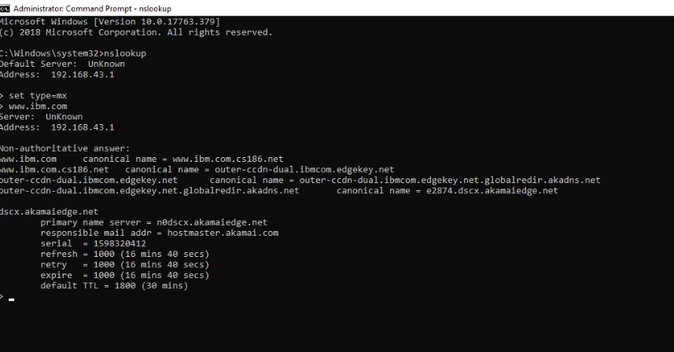

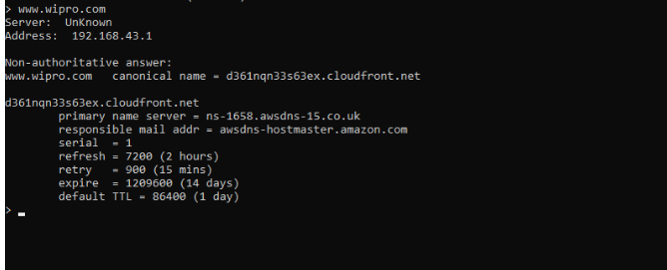

Question 2: Find the locations, where these email servers are hosted.

A) [mail@ibm.com](mailto:mail@ibm.com)

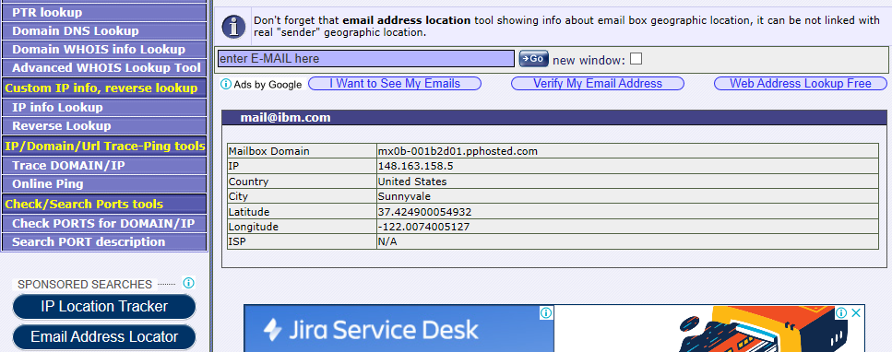

B) [mail@wipro.com](mailto:mail@wipro.com)

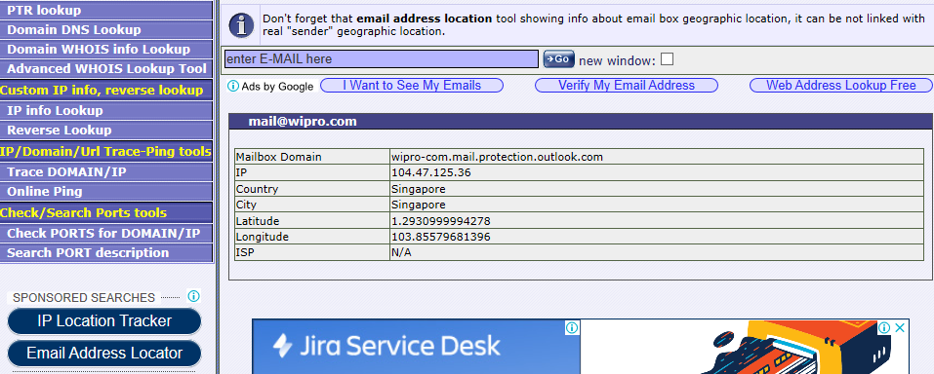

Question 3: Scan and find out port numbers open 203.163.246.23

Commands :

>nmap –T4 –p- -vv 203.163.246.23

>nmap –T4 –p- -vv –A 203.163.246.23

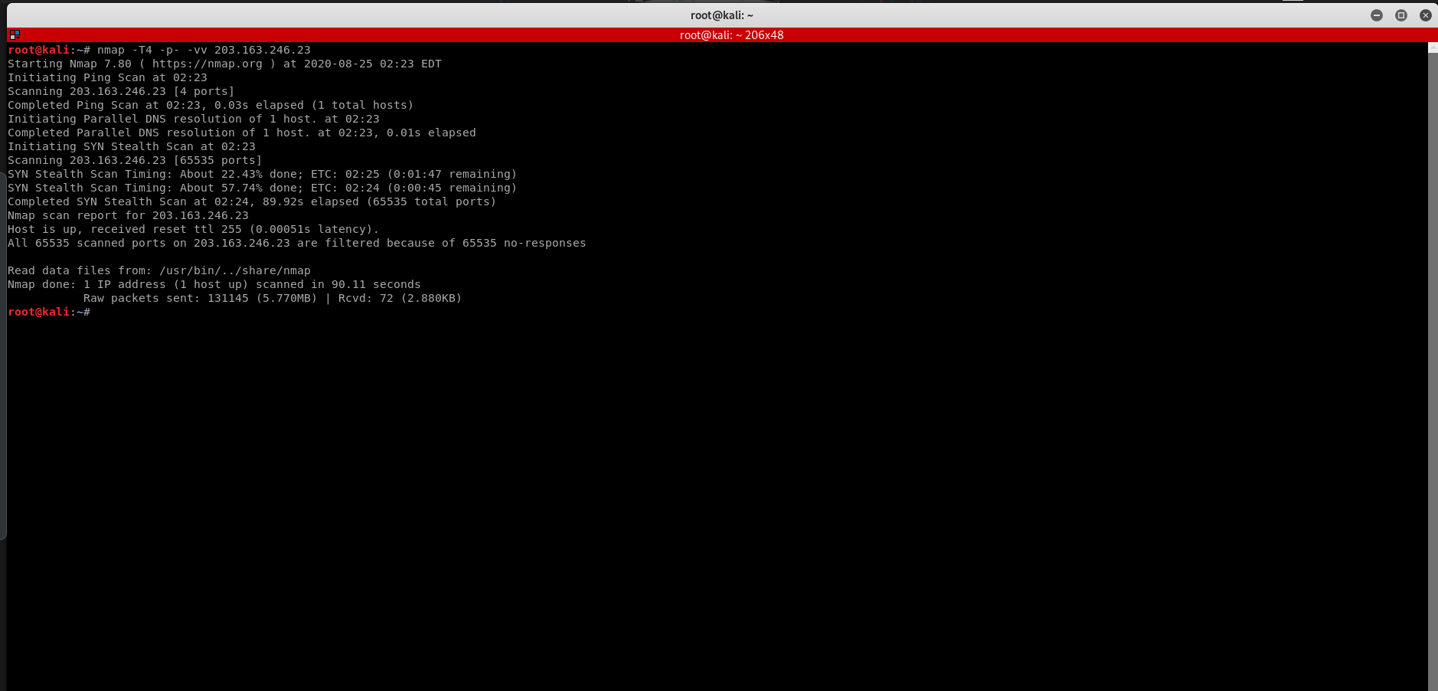

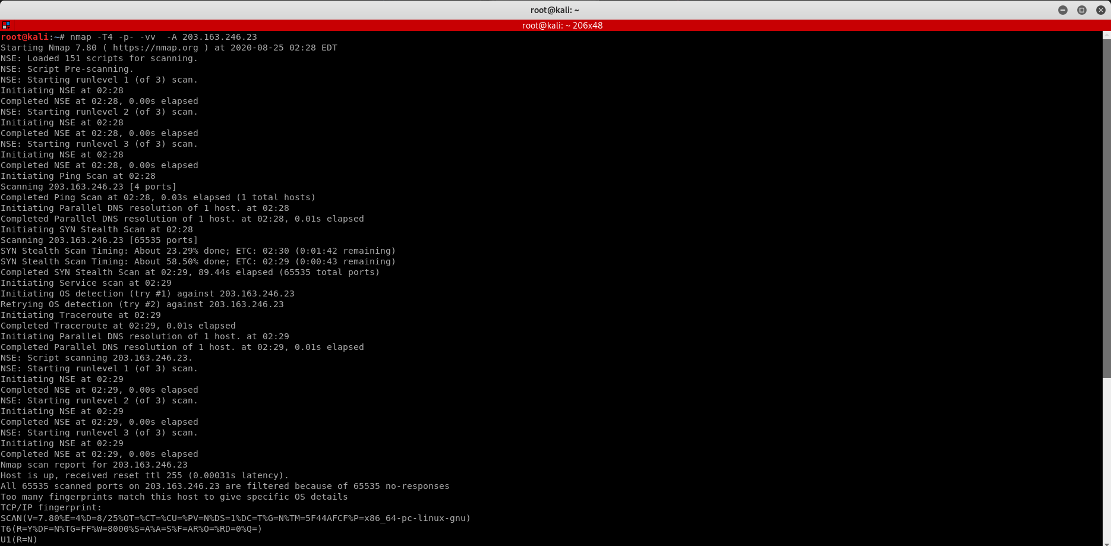

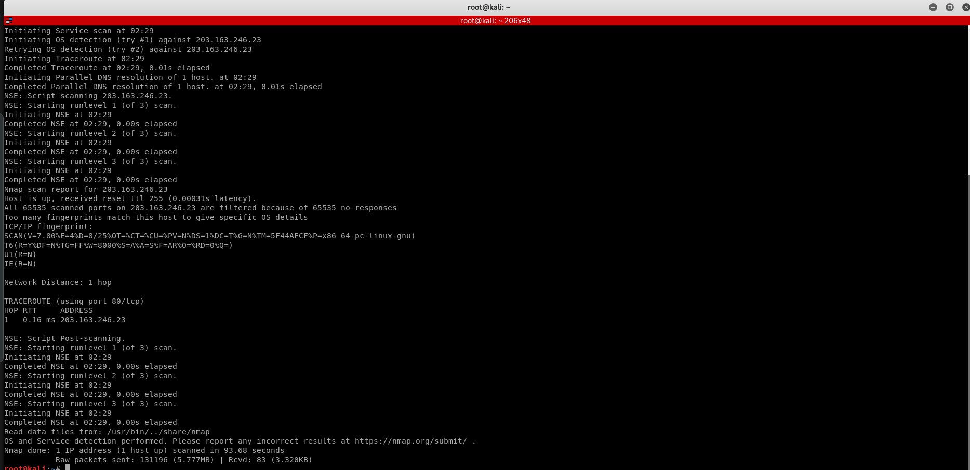

Question 4: Install nessus in a VM and scan your laptop/desktop for CVE.

Commands :

>service nessud start

>service nessud status

>firefox <https://kali:8834/>

>after login goto new scan and select advanced scan.

>set the targets and save the scan .

>come to all scans and start the scan.

